3x3 Observations: December 2009
WORLD LANGUAGES Department – 5 Classes

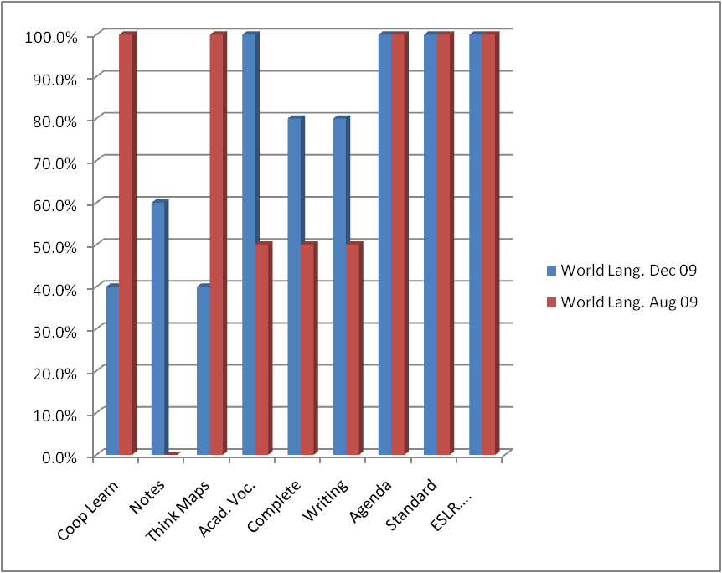

World Languages | Coop Learn | Notes | Think Maps | Acad. Voc. | Complete Sentences | Writing | Agenda | Standard | ESLR….
Dec 09 | 42.9% | 71.4% | 14.3% | 85.7% | 71.4% | 85.7% | 85.7% | 42.9% | 71.4%
Aug 09 | 100.0% | 0.0% | 100.0% | 50.0% | 50.0% | 50.0% | 100.0% | 100.0% | 100.0%

